|  |  |  |
| --- | --- | --- |
|  | **SRI KRISHNA COLLEGE OF TECHNOLOGY**  **An Autonomous Institution | Accredited by NAAC with 'A' Grade**  **Affiliated to Anna University | Approved by AICTE**  **KOVAIPUDUR, COIMBATORE 641042** |  |

**GYM TRAINER TRACKER APPLICATION**

**Software Design Pattern**

**A PROJECT REPORT**

***Submitted by***

**727822TUCS061 – KRISHNA PRAJVIN P**

**727822TUCS011 – ANEES AHAMAD M**

**727822TUCS037 – GIRISHKANTH D**

**727822TUCS056 – KATHIRESH V**

***in partial fulfilment for the award of the degree***

Of

#### BACHELOR OF TECHNOLOGY

**IN**

**Computer Science & Engineering**

**JULY - 2024**

**INTRODUCTION:**

The Gym Management Application is a comprehensive solution designed to streamline and optimize gym operations for fitness centers and health clubs. This application provides an intuitive interface for managing memberships, scheduling classes, and organizing staff shifts. It allows gym managers to efficiently handle member sign-ups, track attendance, and manage class bookings. The application enhances productivity by automating routine tasks, reducing errors, and improving communication between management, trainers, and members. It is designed to accommodate various types of fitness facilities and can be customized to fit specific organizational needs. With its user-friendly interface and robust features, the Gym Management Application aims to simplify operational management and ensure smooth daily operations.

**OBJECTIVE:**

A gym management application is a powerful tool designed to simplify the management of gym operations, including membership tracking and scheduling of fitness classes and personal training sessions. It allows fitness centers to efficiently allocate resources, track member attendance, and manage trainer schedules. By centralizing operational tasks, the application reduces administrative overhead, minimizes scheduling conflicts, and enhances overall operational efficiency. Key features often include automated membership renewals, real-time updates, integration with payment systems, and reporting capabilities to analyze usage patterns and member preferences. User-friendly interfaces ensure that both gym staff and members can easily interact with the system. Ultimately, this application aims to streamline gym management, improve member satisfaction, and support the smooth operation of fitness facilities by ensuring optimal service and resource allocation.

**FLOW CHART:**

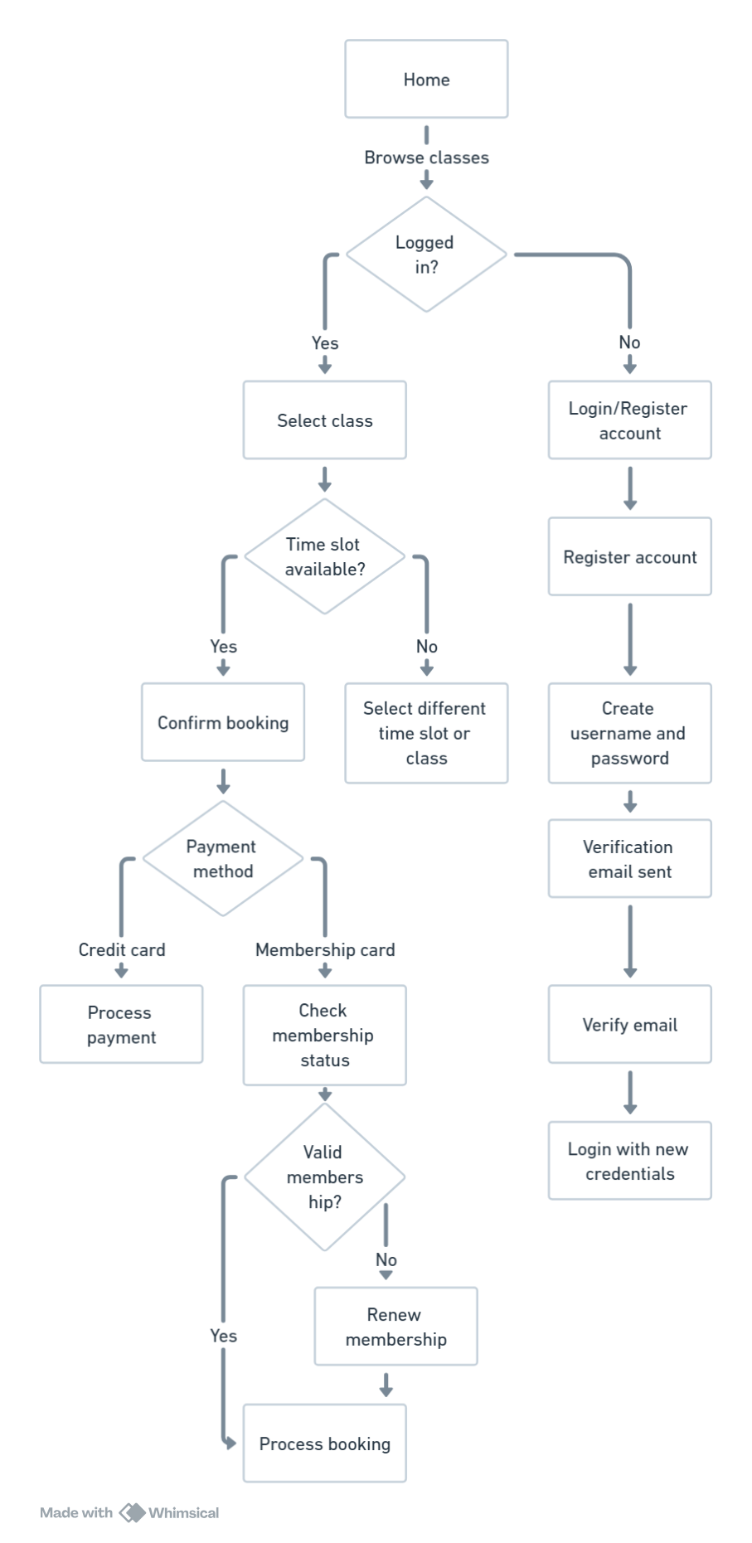

**USER MODULES:**





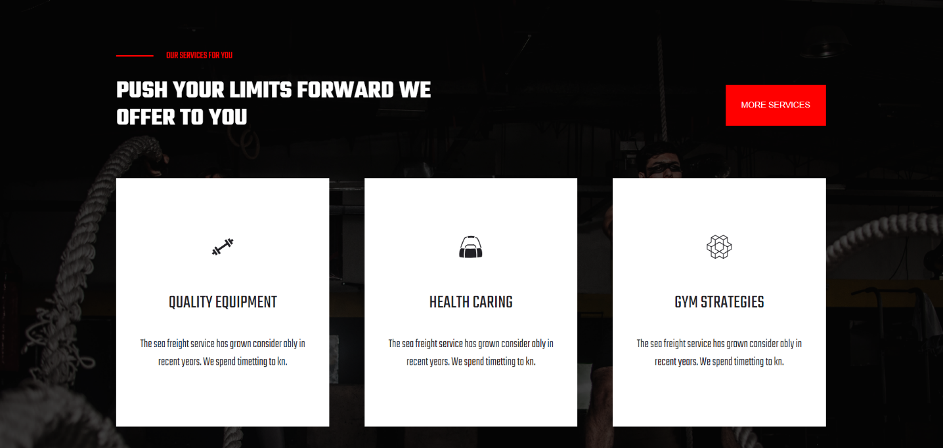

**Home Page**



**Login Page**

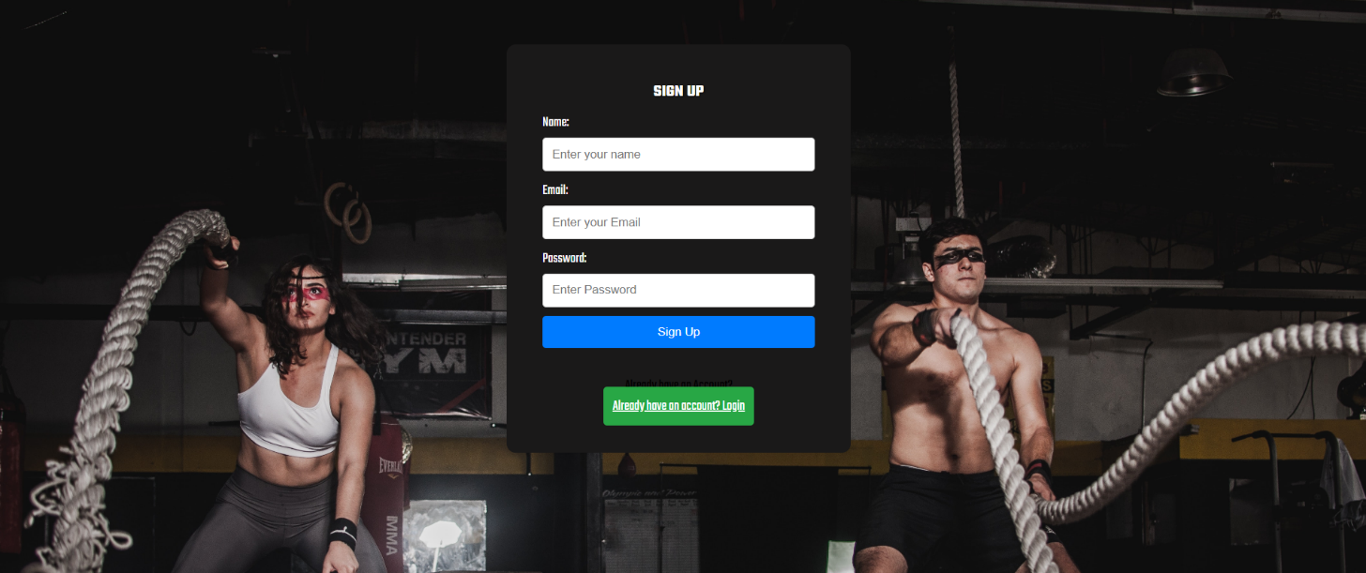

**Sign Up Page**

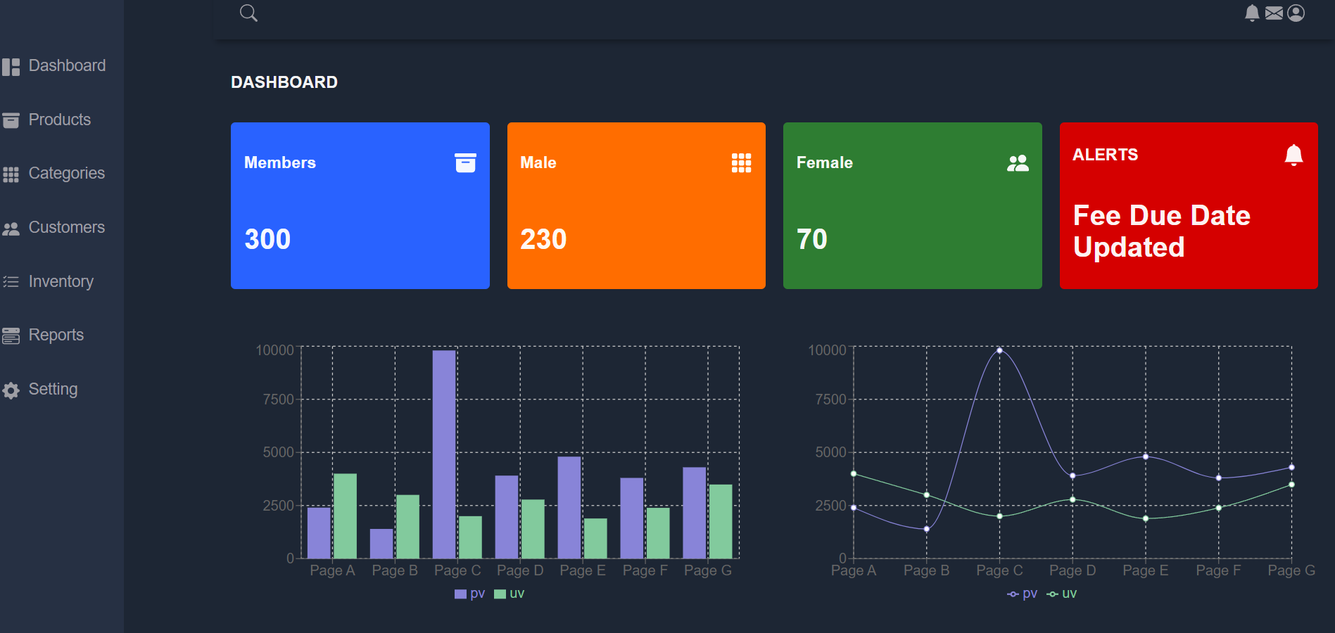

**Dashboard Page**

**CONCLUSION:-**

The development of the Gym Trainer Tracker website using ReactJS has been a significant achievement, offering an efficient and user-friendly platform for gym trainers and clients to manage their fitness routines effectively. By leveraging ReactJS, we were able to build a responsive and dynamic interface that enhances user interaction and provides a seamless experience across various devices.Throughout the project, we focused on creating a robust system that addresses the specific needs of both trainers and clients. Key features such as scheduling, progress tracking, personalized workout plans, and communication tools were implemented to ensure that users can maximize their fitness goals and streamline their daily activities.